**Terraform Final Tasks:**

**1)Create VPC:**

# VPC

resource "aws_vpc" "main" {

  cidr_block           = "10.0.0.0/16"

  enable_dns_support   = true

  enable_dns_hostnames = true

  tags = {

    Name = "Main-VPC"

  }

}

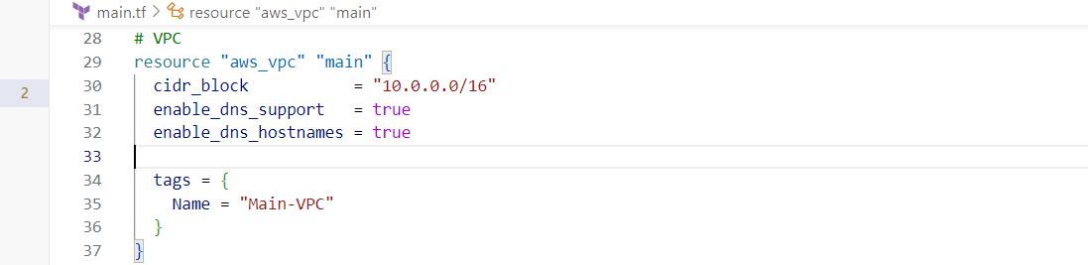

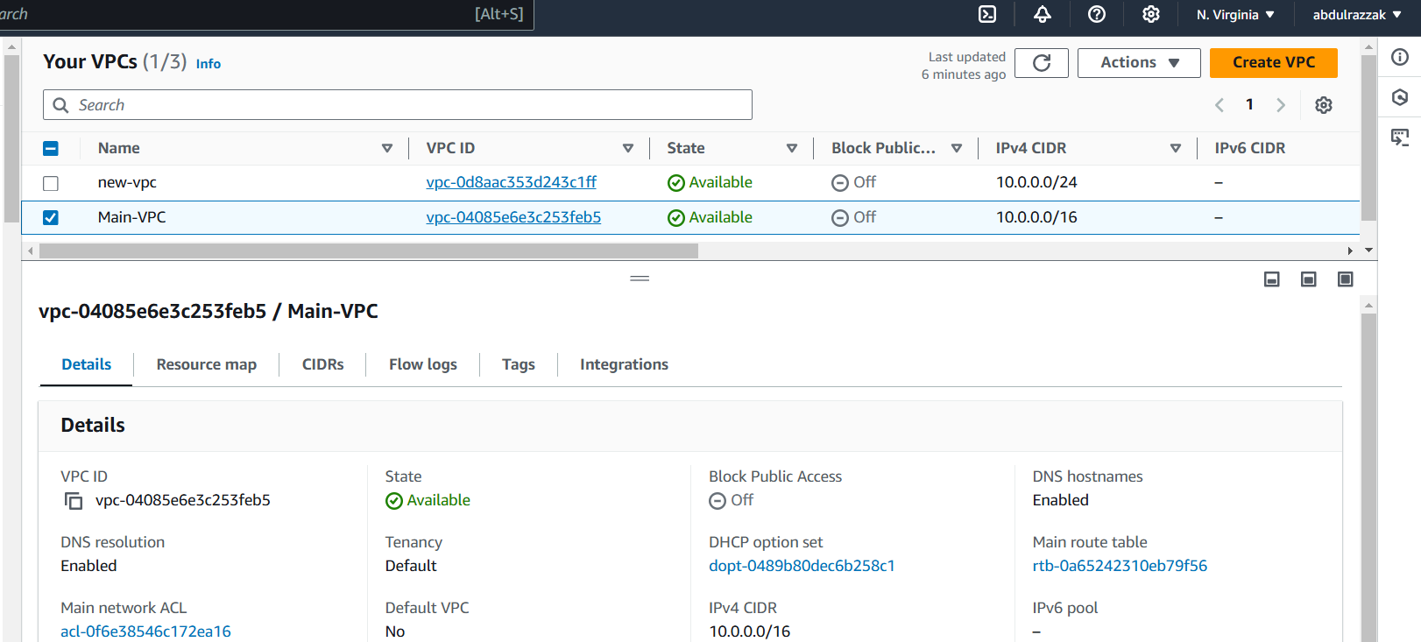

**2) Create Internet gateway:**

resource "aws_internet_gateway" "main" {

  vpc_id = aws_vpc.main.id

  tags = {

    Name = "Main-Internet-Gateway"

  }

}

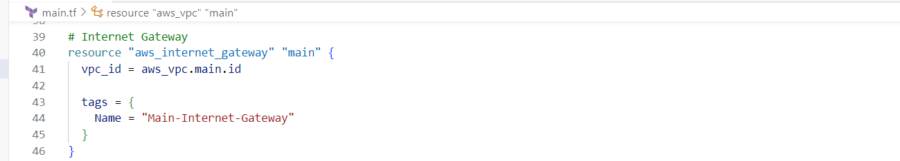

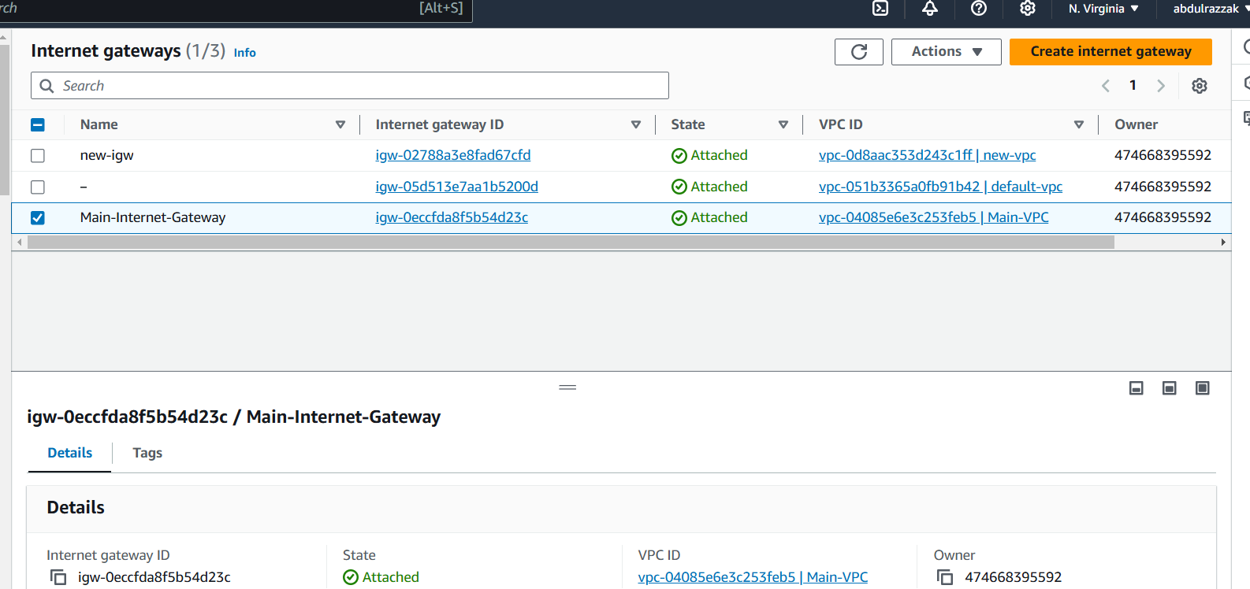

**3) Create Custom Route Table:**

resource "aws_route_table" "main" {

  vpc_id = aws_vpc.main.id

  tags = {

    Name = "Main-Route-Table"

  }

}

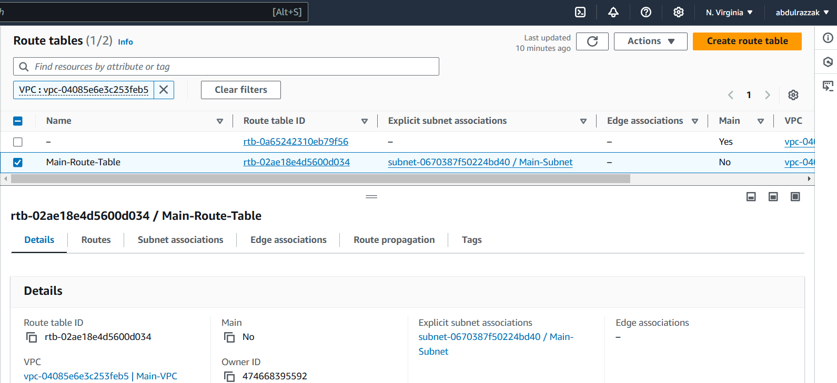

**# Route to allow internet traffic**

resource "aws_route" "internet_access" {

  route_table_id         = aws_route_table.main.id

  destination_cidr_block = "0.0.0.0/0"

  gateway_id             = aws_internet_gateway.main.id

}

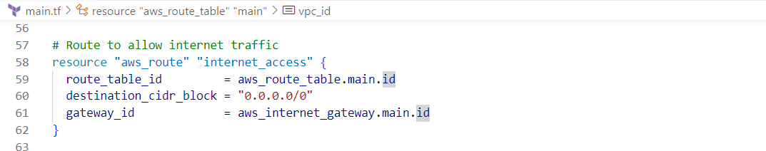

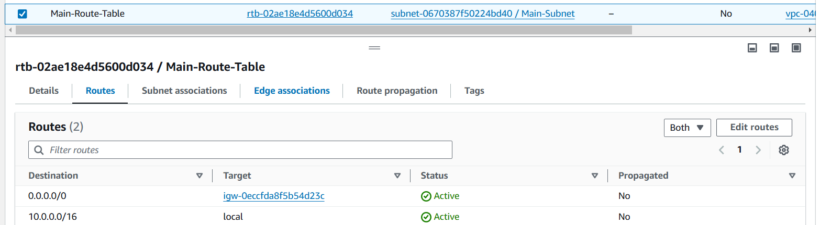

**4) Create Subnet:**

**resource "aws_subnet" "main" {**

**vpc_id                  = aws_vpc.main.id**

**cidr_block              = "10.0.1.0/24"**

**map_public_ip_on_launch = true**

**availability_zone       = "us-east-1a" # Replace with your desired AZ**

**tags = {**

**Name = "Main-Subnet"**

**}**

**}**

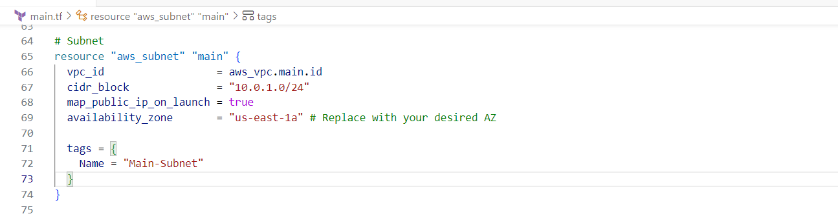

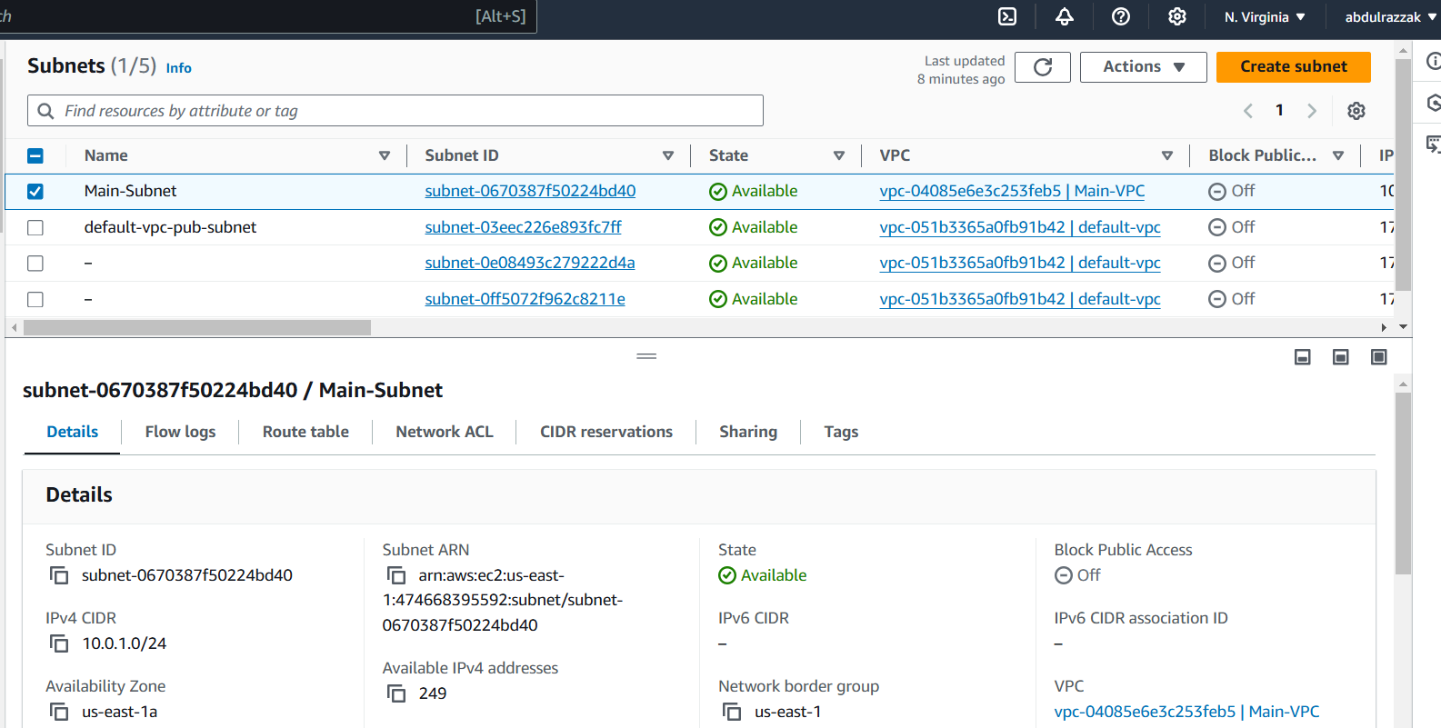

**5) Associate subnet with Route Table:**

**resource "aws_route_table_association" "main" {**

**subnet_id      = aws_subnet.main.id**

**route_table_id = aws_route_table.main.id**

**}**

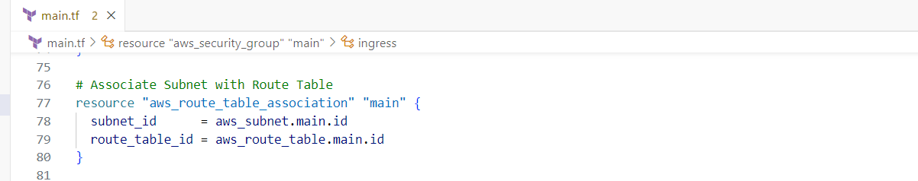

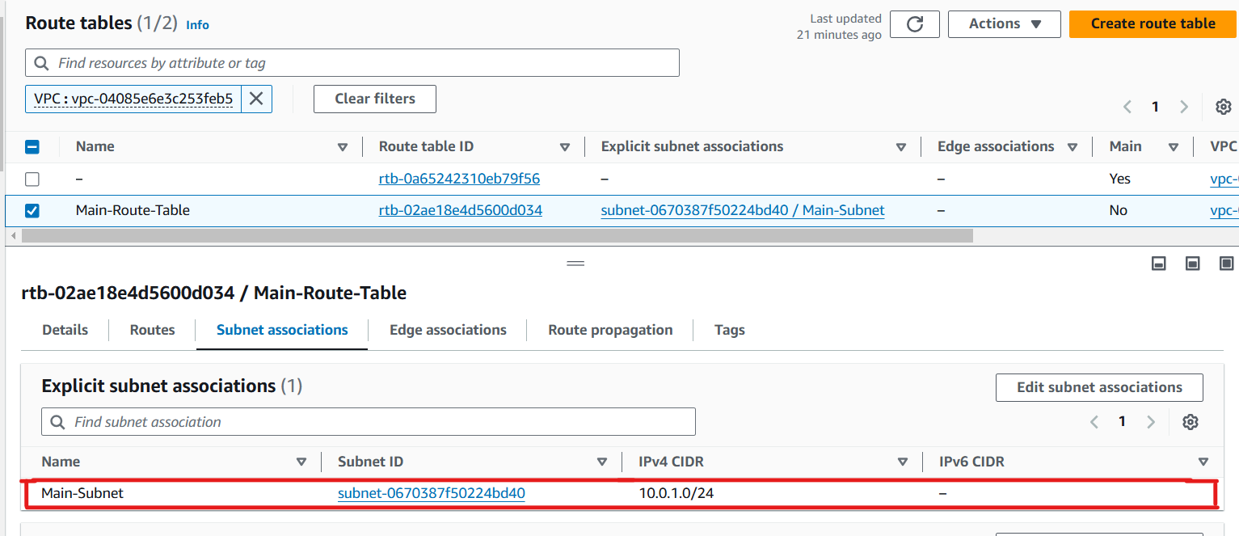

**6) Create Security Group to allow port 22.80,443**

**resource "aws_security_group" "main" {**

**vpc_id = aws_vpc.main.id**

**ingress {**

**from_port   = 22**

**to_port     = 22**

**protocol    = "tcp"**

**cidr_blocks = ["0.0.0.0/0"]**

**}**

**ingress {**

**from_port   = 80**

**to_port     = 80**

**protocol    = "tcp"**

**cidr_blocks = ["0.0.0.0/0"]**

**}**

**ingress {**

**from_port   = 443**

**to_port     = 443**

**protocol    = "tcp"**

**cidr_blocks = ["0.0.0.0/0"]**

**}**

**egress {**

**from_port   = 0**

**to_port     = 0**

**protocol    = "-1"**

**cidr_blocks = ["0.0.0.0/0"]**

**}**

**tags = {**

**Name = "Main-Security-Group"**

**}**

**}**

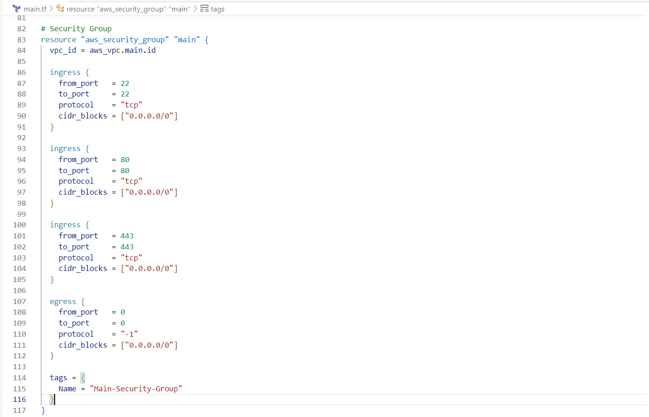

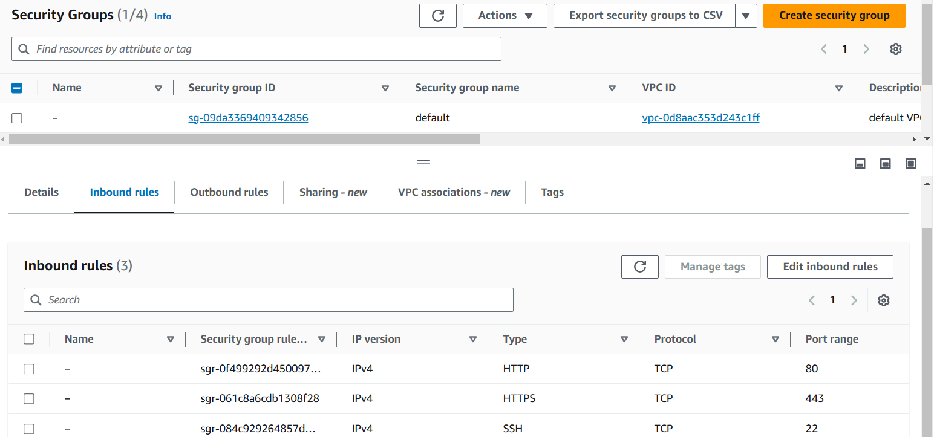

**7) Create a network interface with an ip in the subnet that was created in step 4**

**resource "aws_network_interface" "main" {**

**subnet_id       = aws_subnet.main.id**

**private_ips     = ["10.0.1.10"]**

**security_groups = [aws_security_group.main.id]**

**tags = {**

**Name = "Main-Network-Interface"**

**}**

**}**

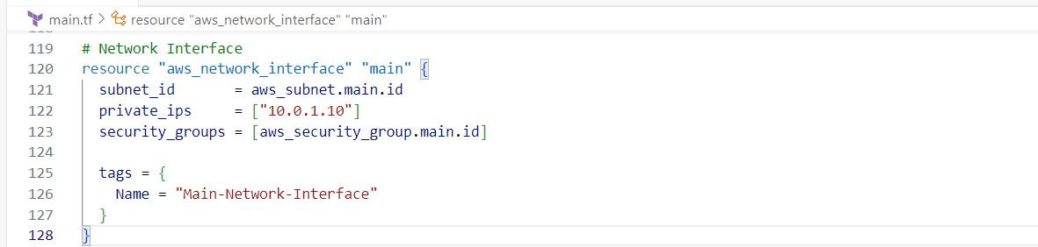

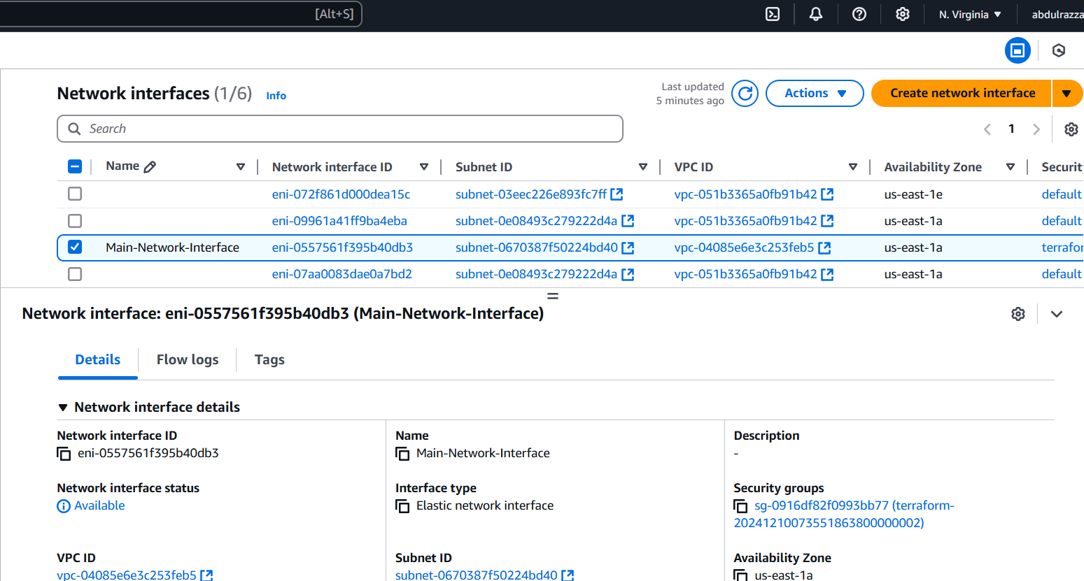

**8) Assign an elastic IP to the network interface created in step 7**

**resource "aws_eip" "main" {**

**network_interface = aws_network_interface.main.id**

**vpc               = true**

**tags = {**

**Name = "Main-EIP"**

**}**

**}**

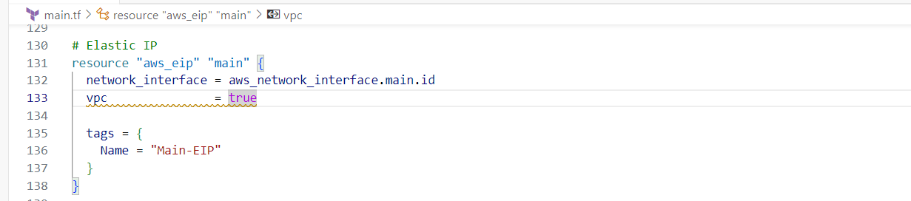

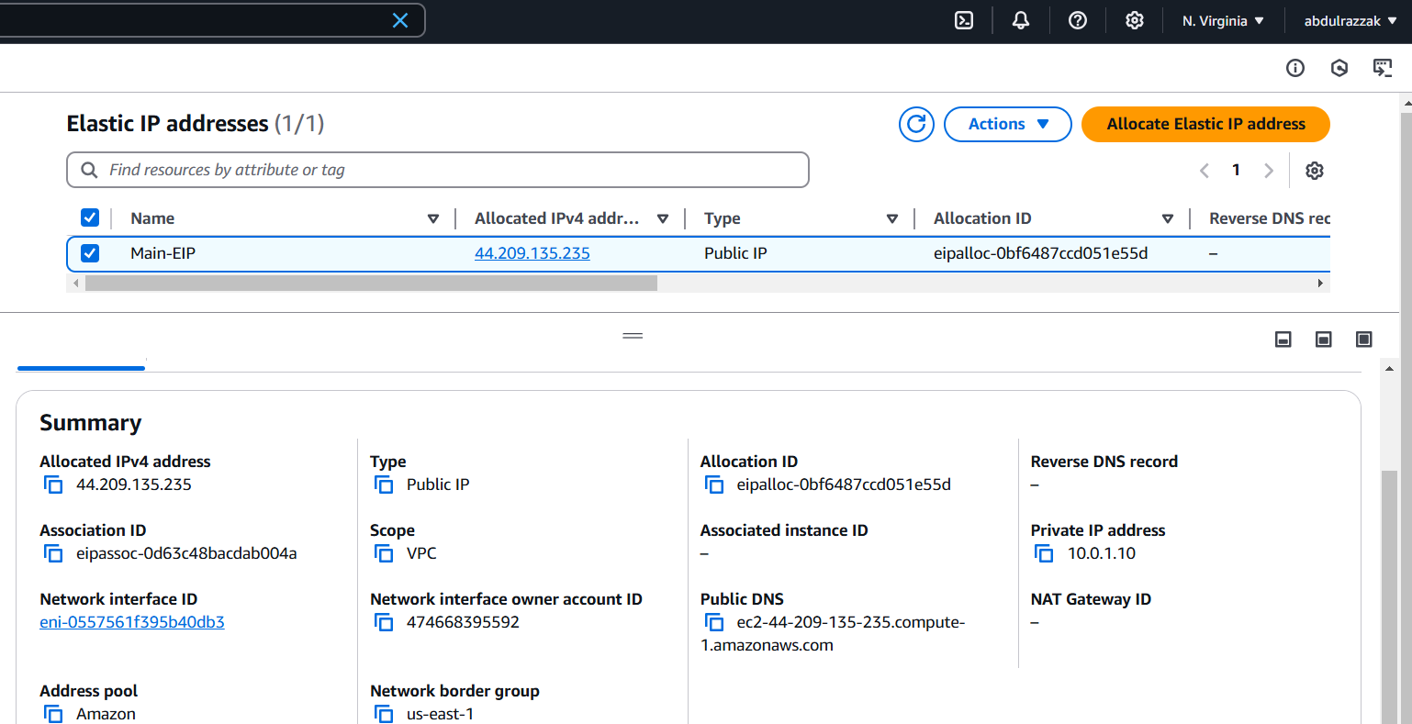

**9) Create Ubuntu server and install/enable apache2**

**resource "aws_instance" "ubuntu" {**

**ami                    = "ami-0e2c8caa4b6378d8c"**

**instance_type          = "t2.micro"**

**subnet_id              = aws_subnet.main.id**

**associate_public_ip_address = true**

**tags = {**

**Name = "Ubuntu-Server"**

**}**

**user_data = <<-EOF**

**#!/bin/bash**

**apt-get update -y**

**apt-get install -y apache2**

**systemctl enable apache2**

**systemctl start apache2**

**EOF**

**}**

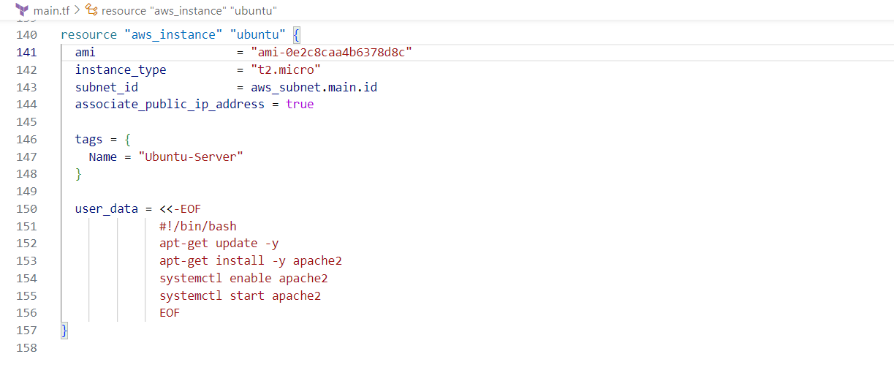

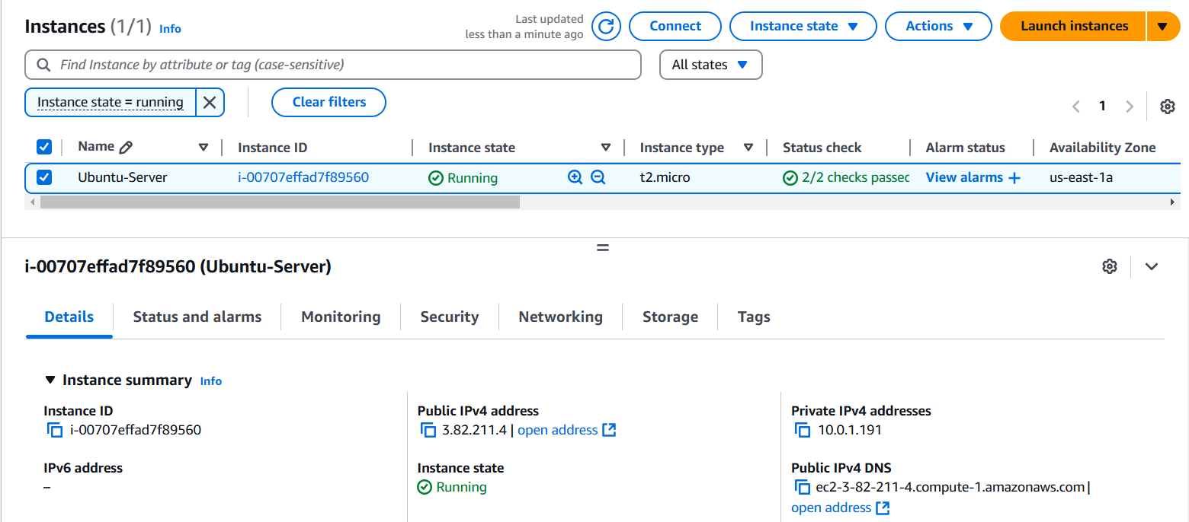

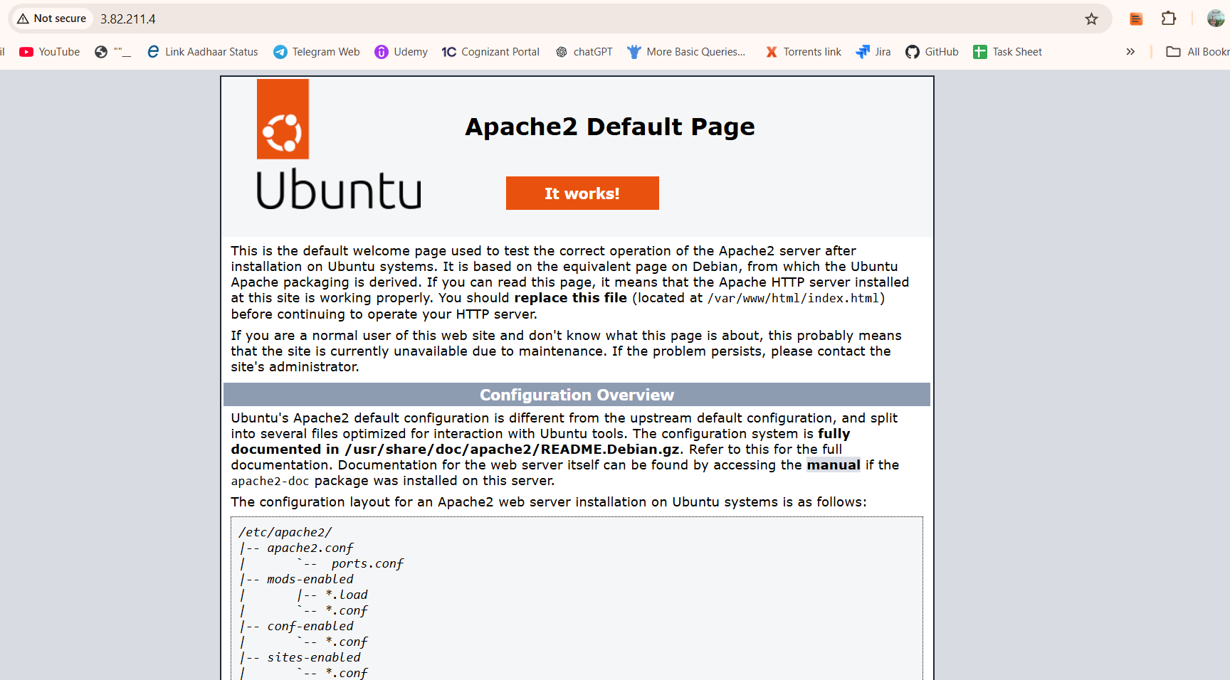

* **Configure s3 as backend and dynamo db locking for multi user execution.**

resource "aws_s3_bucket" "s3_bucket" {

  bucket = "s3-10-dec-2024"

  acl = "private"

}

resource "aws_dynamodb_table" "dynamodb-terraform-state-lock" {

  name = "terraform-state-lock-dynamo"

  hash_key = "LockID"

  read_capacity = 20

  write_capacity = 20

  attribute {

    name = "LockID"

    type = "S"

  }

}

terraform {

  backend "s3" {

    bucket = "s3-10-dec-2024"

    dynamodb_table = "terraform-state-lock-dynamo"

    key    = "terraform.tfstate"

    region = "us-east-1"

  }

}

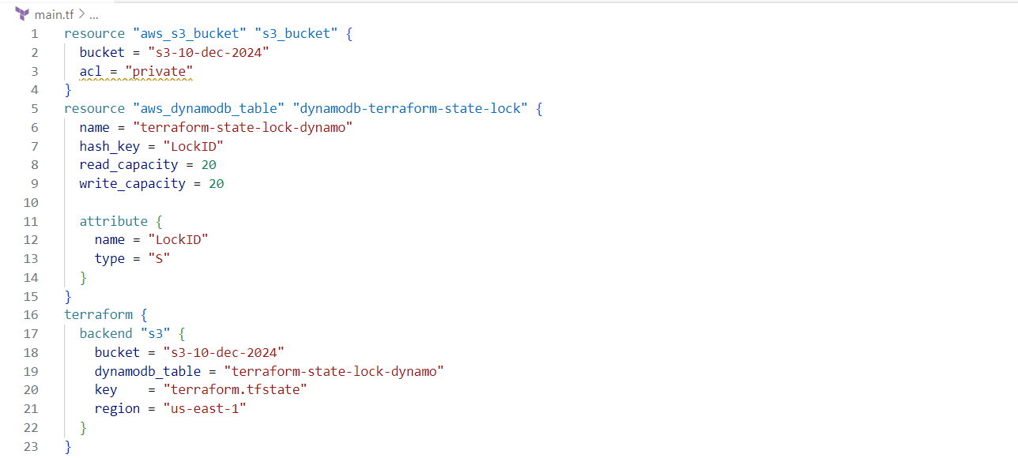

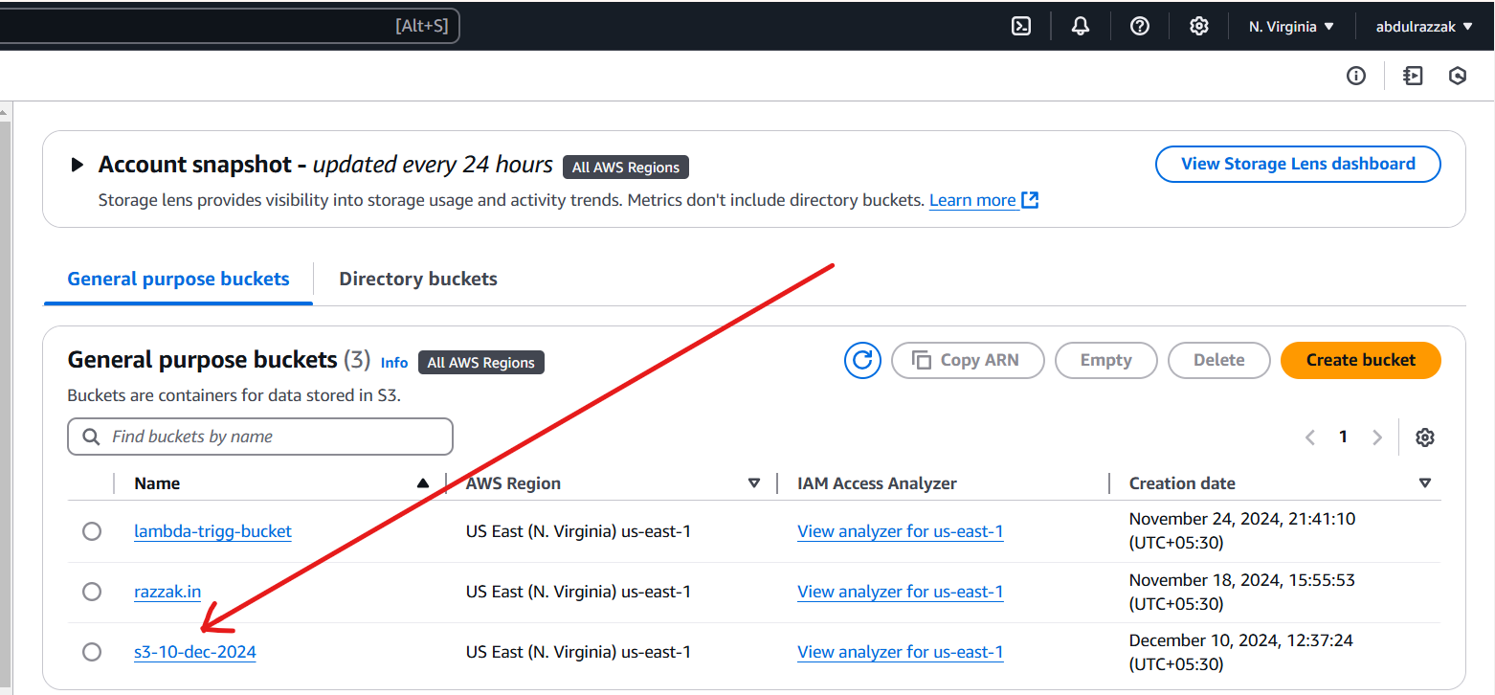

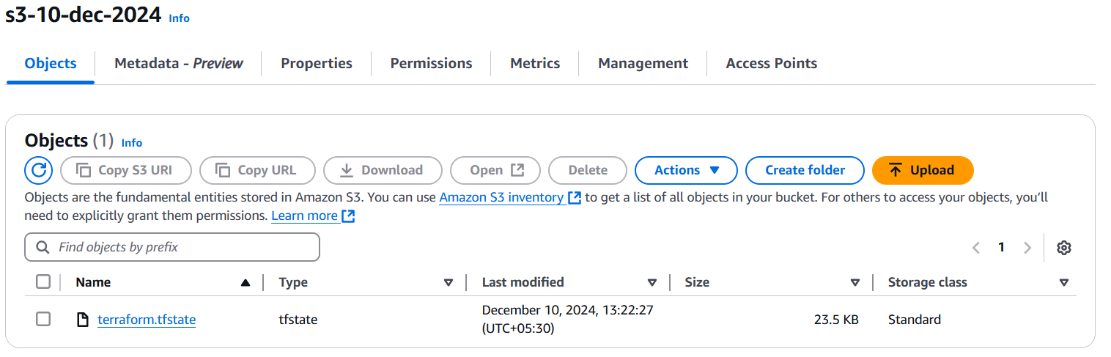

**>>>Dynamo Table:**

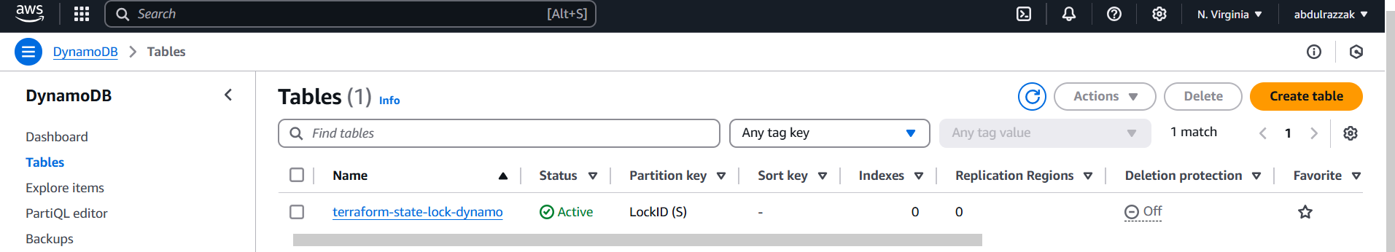

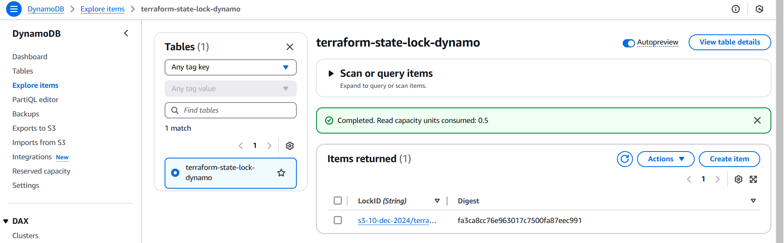

**>>>Lock Id:**

